
CS 255 System Design Document Template

Derek Spaulding

UML Diagrams

UML Use Case Diagram

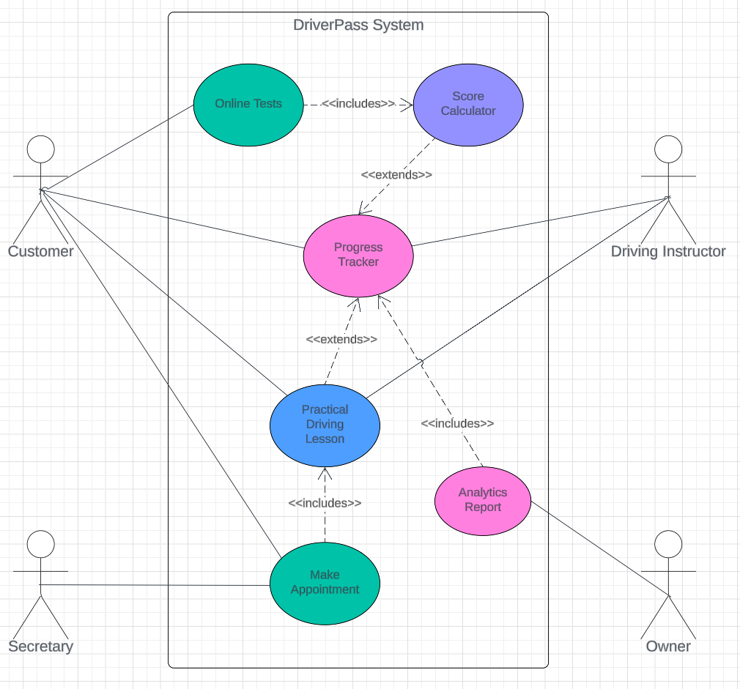

UML Activity Diagrams
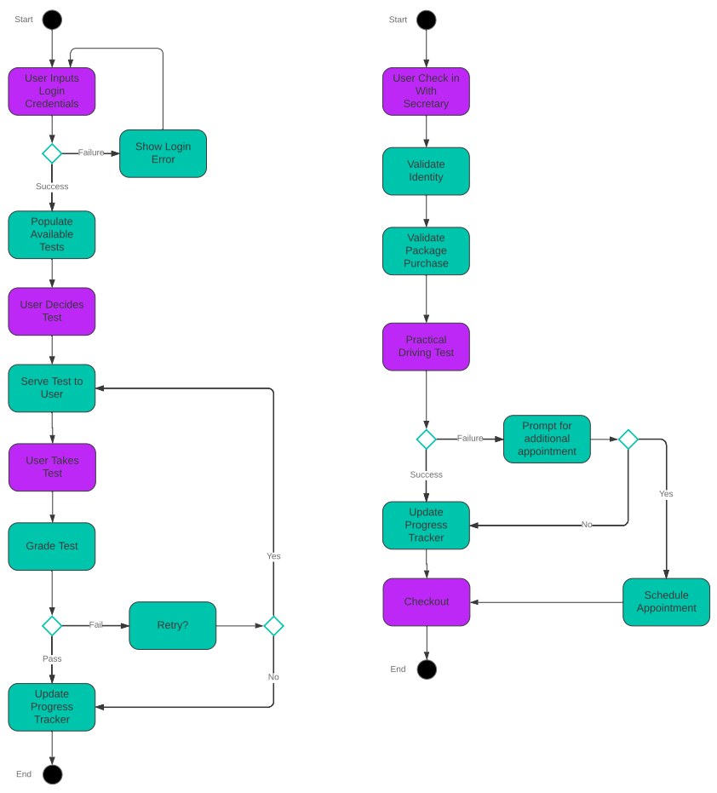

UML Sequence Diagram
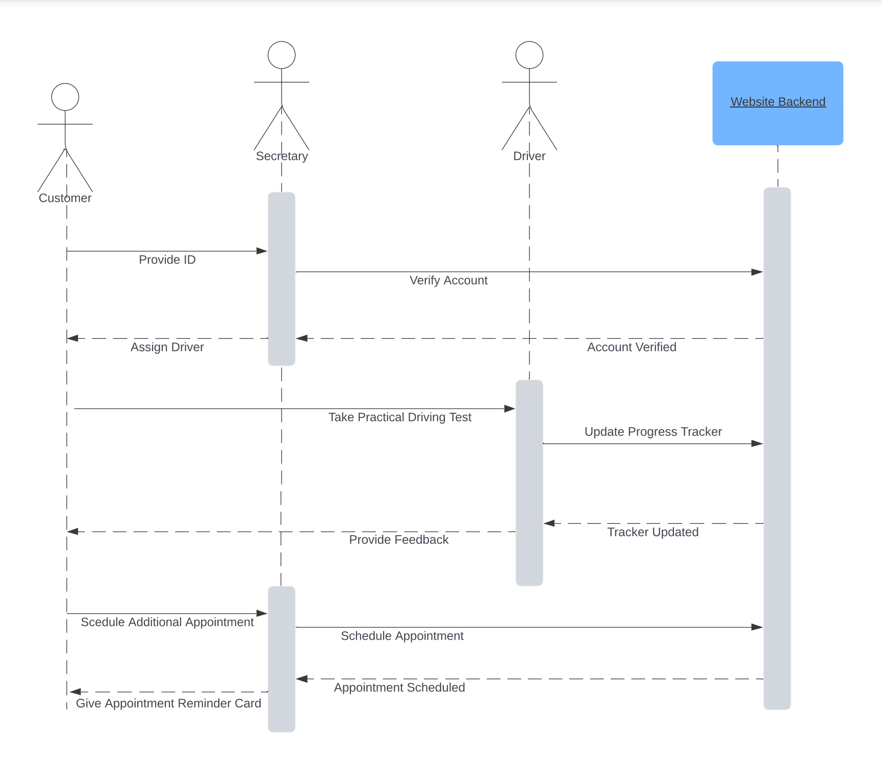

UML Class Diagram
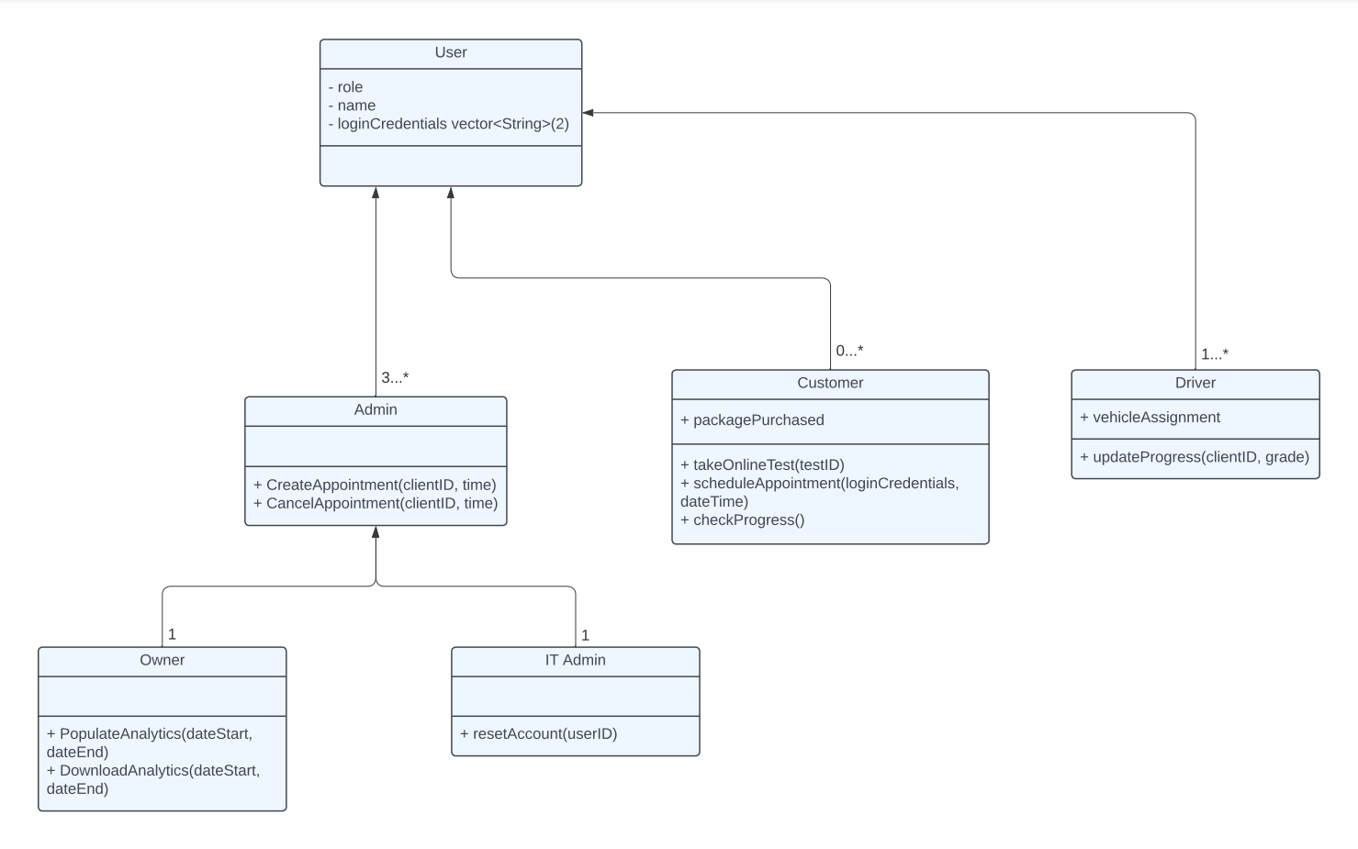

Technical Requirements

To start off with the initial system requirements for the DriverPass system, there needs to be a back end that is hosted on the cloud. The client wishes for the system to be kept there, and interfaces through the system will require an internet connection. The internet connection is going to be required for all use cases of the system. This will also mean that there needs to be hardware and a front end capable of interacting with the back end. The secretary will need a computer with a web browser capable of loading the front end to interact with the DriverPass system. Also, customers are going to be required to either be able to walk in or visit online to make appointments.
With the back end being hosted on a cloud-based service, a requirement needed is tooling for whatever service gets chosen. Places like Microsoft Azure, AWS, and Google Cloud, all have their own tools for database management and event logging.
The front-ends need to have 3 variants, a customer front end, secretary, and administrator. The owner and IT admin should have access to the administrator front end, which allows for downloading analytical data for the owner, or viewing event logs of the system. Next, the secretary's front end should allow for creation/manipulation of appointment data of the system. Then, the customer should be allowed to create an account, pay for packages, and interact with testing services provided by the DriverPass system.
Another technical requirement is the allowance of a payment processing system to be incorporate into the solution. Some that come to mind are Stripe or Paypal, two very popular and widely used solutions.

